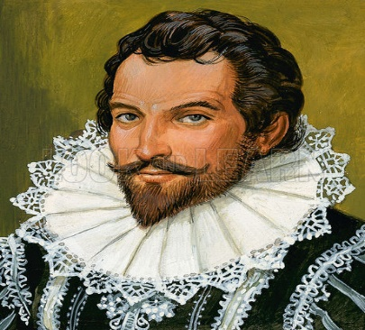
Budleigh Library “Sir Walter Raleigh” childrens drawing competition.
Sir Walter Raleigh was born in East Budleigh and was a famous courtier and a favourite of Queen Elizabeth 1st. He was also a soldier, explorer, writer, poet and possibly a spy. To help remember the life of this extraordinary Devonian we’d like you to draw a picture of Sir Walter Raleigh. You can draw your picture on the back of this entry form or on a separate piece of A4 paper.
The competition is divided into three age groups –
5 years and under – 6 to 10 years – 11 years plus
Prizes will be awarded to one person in each age group and all entries must be handed into the library by 5.30 pm on 31st May.
All pictures will go on display in Budleigh Library.
Name:
Age:
Phone number:
